Slice buffer design

Table of Contents

1. Overview for new design 3

.1. Origin design 3

1.1.1. Single thread 3

1.1.2. Multi thread 4

i. 4

1.2 New design in review 5

1.2.1 Single thread 5

1.2.2. Multi-thread 6

2. Slice Buffer and thread 7

2.1 Before encoding one layer 7

2.2. Normal case for thread index and slice buffer index 9

2.3. Slice num not the same among threads 10

2.4. Different thread index in the same slice buffer 12

2.5. Slice index out-of-order case 13

2.6. Dynamic slice mode case1 14

2.7. Dynamic slice mode case2 15

3. Slice Buffer Init/Update/Reorder 16

3.1. Allocate and initial before encode first IDR 16

3.2 Slice buffer info before encoder one layer 17

3.3.1 basic flow chart for encoding one slice task 18

3.3.2 Task manager 19

3.3.3. InitTask before encode one slice 20

3.3.4 Slice buffer update/reallocate during execute task 21

3.4. Slice buffer update after encoder one layer 22

3.4.1. ppSliceInLayer update: extend and reallocate ppSliceInLayer buffer, 22

ppSliceInLayer buffer num == All thread slice buffer num 22

3.4.2. Slice buffer reorder 23

4. Bs buffer design 25

4.1. Slice Bs buffer 25

4.2. Frame bs buffer 26

4.3 pCtx-pOut 27

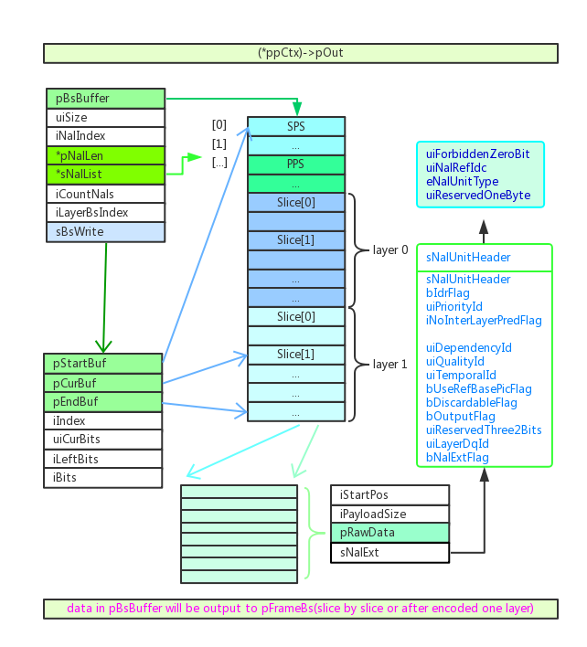 27

4.4. dynamic slice, slice boundary strategy 28

# Overview for new design

## Origin design

SSlice* pSliceInLayer // slice buffer for all slices in layer

### 1.1.1. Single thread

pSliceInLayer

…

…

…

Slc3

Slc2

Slc1

Slc0

**reallocate** when current slice index larger than max slice num

…

pSliceInLayer

Slc2

Slc1

Slc0

Slc0

Slc1

Slc2

…

…

…

…

### 1.1.2. Multi thread

pSliceInLayer

Slc0

Slc1

Slc2

Slc3

…

…

Thrd0

Thrd1

**reallocate** when current slice index larger than max slice num ,

--step 0: thread[0] detect that current slice index larger than max slice num;

--step 1: thread[0] need to wait thread[1] completed current slice encoding task

--step 2: thread[1] stop slice encoding and thread[0] reallocate slice buffer,

--step 3: thread[0]/thread[1] start to encode new slice

pSliceInLayer

Slc0

Slc1

Slc2

...

**Step 0/1**

Thrd1

Thrd0

Thrd0

pSliceInLayer

Slc0

Slc1

Slc2

…

**Step 2**

Slc0

Slc1

Slc2

...

…

…

…

**Step 3**

Thrd2

Thrd0

## 

## 1.2 New design in review

SSlice** ppSliceInLayer; // point to actual slice buffer

typedef struct TagSliceThreadInfo {

SSlice*                 pSliceInThread;// slice buffer for multi thread,

                                       // pSliceInThread[0] for single thread

int32_t                 iMaxSliceNum;

int32_t                 iCodedSliceNum;

}SSliceThreadInfo;

### 1.2.1 Single thread

Slc0

Slc1

Slc2

…

ppSliceInLayer

pSliceInThread_0

Slc0

Slc1

Slc2

…

**reallocate** when current slice index larger than max slice num

Slc0

Slc1

Slc2

…

ppSliceInLayer

pSliceInThread_0

Slc0

Slc1

Slc2

…

Slc0

Slc1

Slc2

Slc3

…

…

**reallocate**

…

Slc0

Slc1

Slc2

Slc3

…

### 1.2.2. Multi-thread

Slc0

Slc1

Slc2

Slc3

Slc4

…

ppSliceInLayer

pSliceInThread_0

Slc4

Slc2

Slc0

…

Slc1

Slc3

Slc5

…

pSliceInThread_1

**for reallocate**, each thread will do it independently, and will update ppSliceInLayer by ***main thread*** when all slices in layer are encoded.

ppSliceInLayer

…

Slc4

Slc3

Slc2

Slc1

Slc0

**Main thread**

Slc0

Slc1

Slc2

Slc3

Slc4

…

…

Slc4

Slc2

Slc0

…

…

Slc0

Slc2

Slc4

…

…

Slc1

Slc3

Slc5

…

…

**Thread 1**

pSliceInThread_0

**Reallocate**

**/update**

**Reallocate**

**Thread 0**

pSliceInThread_1

# 2. Slice Buffer and thread

## 2.1 Before encoding one layer

the status of slice buffer and thread :

example:

thread: 3 threads

slices: 9 slices in layer

bThreadBufferUsage[iThrdIdx] = false

**Slice buffer**

pSliceInThread_1

pSliceInThread_2

pSliceInThread_0

Thrd_0

**Idle**

**thread**

Thrd_2

Thrd_1

**Get_UnUsed_Buffer()**

slice in layer

Get_Idle_Thrd()

Slc8

Slc1

Slc2

Slc0

….

**Slice tasks**

Get_waiting_task()

**Task manager**

Encode_One_Slice()

Query thread buffer function:

int32_t CWelsSliceEncodingTask::QueryEmptyThread (bool* pThreadBsBufferUsage) {

  for (int32_t k = 0; k < MAX_THREADS_NUM; k++) {

    if (pThreadBsBufferUsage[k] == false) {

      pThreadBsBufferUsage[k] = true;

      return k;

    }

  }

  return -1;

}

Example:

k=1, means that encode slice task using pSliceInThread_0 as slice buffer

Query IDLE thread for slice task function:

CWelsTaskThread*   CWelsThreadPool::GetIdleThread() {

  CWelsAutoLock cLock (m_cLockIdleTasks);

  if (m_cIdleThreads->size() == 0) {

    return NULL;

  }

  CWelsTaskThread* pThread = m_cIdleThreads->begin();

  m_cIdleThreads->pop_front();

  return pThread;

}

## 2.2. Normal case for thread index and slice buffer index

**Task manager**

Thrd_2

Slice_2

pSliceInThread _2

Thrd_1

Slice_1

pSliceInThread _1

Thrd_0

Slice_0

pSliceInThread _0

Thrd_2

Slice_8

pSliceInThread _2

…

…

…

Final map for thread index and slice buffer index, slice index

ppSliceInLayer

Slc0

Slc1

Slc2

Slc3

…

Slc8

pSliceInThread _0

Slc6

Slc3

Slc0

Slc1

Slc4

Slc7

pSliceInThread _1

Thrd_0

Thrd_1

Thrd_2

pSliceInThread _2

Slc8

Slc5

Slc2

## 2.3. Slice num not the same among threads

case 1:

ppSliceInLayer

Slc0

Slc1

Slc2

Slc3

…

Slc8

Slc0

Slc3

pSliceInThread_0

Thrd_0

Thrd_1

Slc7

Slc1

Slc4

pSliceInThread_1

Slc6

Thrd_2

pSliceInThread_2

Slc8

Slc5

Slc2

case 2:

encode time for Slc0 and Slc_2 are longer than Slc1, Slc3~Slc8

ppSliceInLayer

Slc0

Slc1

Slc2

Slc3

…

Slc8

Slc0

pSliceInThread_0

Thrd_0

Thrd_1

Slc8

Slc1

Slc3

pSliceInThread_1

…

Thrd_2

pSliceInThread_2

Slc2

Corner case 1, no encoded slice for one thread:

Thread_0 and Thread_1 are fast enough and always get CPU resource,

Thread_2 is under waiting status/IDLE status.

ppSliceInLayer

Slc0

Slc1

Slc2

Slc3

…

Slc8

Slc0

Slc2

pSliceInThread_0

Thrd_0

Thrd_1

Slc7

Slc1

Slc3

pSliceInThread_1

…

Thrd_2

pSliceInThread_2

Corner case 2, all slices encoded by one thread :

Thread_0 is fast enough and always get CPU resource,

Thread_1 and Thread_2 are under waiting status/IDLE status.

ppSliceInLayer

Slc0

Slc1

Slc2

Slc3

…

Slc8

Thrd_0

…

Slc1

Slc0

Slc8

pSliceInThread_0

Thrd_1

pSliceInThread_1

Thrd_2

pSliceInThread_2

## 2.4. Different thread index in the same slice buffer

Timing diagram for Thread—SlcTask—ThreadBuffer



## 2.5. Slice index out-of-order case



## 2.6. Dynamic slice mode case1

**Partition_0**: **Slc0, Slc3**

Slc0

Slc3

**Partition_1:** **Slc1, Slc4,Slc7,Slc10**

Slc1

Slc4

Slc7

Slc10

Slc5

Slc8

Slc5

Slc2

**Partition_2:** **Slc2, Slc5, Slc8**

Slice_Index = PartitonID + Partition_Num * Slice_Index_InPartition

Example: Slc7 = 1 + 3 * 2

Slc5 = 2 + 3* 1

Slice_Index_InLayer = PartitonOffset [Partiton_ID]+ Slice_Index / Partition_Num

Here in example, PartitonOffset[0] = 0;

PartitonOffset[1] = 0 + 2 =2;

PartitonOffset[2] = 0 + 2+ 4 = 6;

Slc7 = PartitonOffset[1] + 7 / 3 = 2 + 2 = 4;

Which ppSliceInLayer[4] = Slc7

Slc8

…

Slc3

Slc2

Slc1

Slc0

ppSliceInLayer

Slc2

Slc5

Slc8

pSliceInThread_2

Thrd_2

Slc7

pSliceInThread_1

Slc4

Slc1

Thrd_1

Slc10

Slc0

Slc3

pSliceInThread_0

Thrd_0

## 2.7. Dynamic slice mode case2

**Thread_0 encoded two partitions**

**while no partition for Thread_2**

**Partition_0**: **Slc0, Slc3**

Slc0

Slc3

**Partition_1:** **Slc1, Slc4,Slc7,Slc10**

Slc1

Slc4

Slc7

Slc10

Slc5

Slc8

Slc5

Slc2

**Partition_2:** **Slc2, Slc5, Slc8**

Slice_Index = PartitonID + Partition_Num * Slice_Index_InPartition

Example: Slc7 = 1 + 3 * 2

Slc5 = 2 + 3* 1

Slice_Index_InLayer = PartitonOffset [Partiton_ID]+ Slice_Index / Partition_Num

Here in example, PartitonOffset[0] = 0;

PartitonOffset[1] = 0 + 2 =2;

PartitonOffset[2] = 0 + 2+ 4 = 6;

Slc7 = PartitonOffset[1] + 7 / 3 = 2 + 2 = 4;

Which ppSliceInLayer[4] = Slc7

Slc8

…

Slc3

Slc2

Slc1

Slc0

ppSliceInLayer

pSliceInThread_2

Slc7

pSliceInThread_1

Slc4

Slc1

Slc10

Thrd_0

Slc8

Slc5

Slc2

Slc0

Slc3

pSliceInThread_0

Thrd_2

Thrd_1

# 3. Slice Buffer Init/Update/Reorder

## 3.1. Allocate and initial before encode first IDR

* Allocate pSliceInThread buffer
* Allocate ppSliceInLayer buffer
* Allocate pFirstMbIdxOfSlice and pCountMbNumInSlice buffer

Init slice boundary info



## 3.2 Slice buffer info before encoder one layer

* Set iCodedSliceNum = 0 for all thread buffer
* Set iSliceIdx = -1 for all slice buffer (will set to actual slice idx during encoding one slice)
* Init RC info for all slice level parameters
* Init reference pic info for all slices using ppSliceInLayer[iSlcIdx]



**3.3 Slice buffer init/update/reallocate during encoding one slice**

### 3.3.1 basic flow chart for encoding one slice task

* Task manager: Get idle thread, unused thread buffer, and encoding slice
* Init task: Init slice boundary info etc.
* Excute task: Encode one slice etc



### 3.3.2 Task manager

* Get unused thread buffer, in this example, choose Buf_1 as slice buffer
* Get Idle thread, thread_2
* Get encode slice index in layer which will be encoded in this task, Slc_7



### 3.3.3. InitTask before encode one slice

* init rc with boundary info
* update next slice boundary(start MB index etc.)



### 3.3.4 Slice buffer update/reallocate during execute task

* check whether need to reallocate
* init m_pSlice buffer
* update thread buffer info, iCodeSliceNum ++



## 3.4. Slice buffer update after encoder one layer

### 3.4.1. ppSliceInLayer update: extend and reallocate ppSliceInLayer buffer,

### ppSliceInLayer buffer num == All thread slice buffer num



### 3.4.2. Slice buffer reorder

example 1



**Example 2**  Slice index in different slice mode.

Dynamic slice mode

**Partition_0**: **Slc0, Slc3**

Slc0

Slc3

**Partition_1:** **Slc1, Slc4,Slc7,Slc10**

Slc1

Slc4

Slc7

Slc10

Slc5

Slc8

Slc5

Slc2

**Partition_2:** **Slc2, Slc5, Slc8**

Slc0

Slc1

Slc2

Slc3

…

Slc8

ppSliceInLayer

Non-dynamic slice mode

Slc0

Slc1

…

Slc8

Slc2

Slc3

# 4. Bs buffer design

## 4.1. Slice Bs buffer

**Slice Buffer**

**Recycle used**

1. For thread slices, refer to InitBits()

pCtx->pSliceThreading->pThreadBsBuffer

2. Single thread,

replace by pOut->pBsBuffer

SWelsSliceBs sSliceBs

SBitStringAux* pSliceBsa

……

……

iStartPos

iPayloadSize

pRawData

pEndBuf

pCurBuf

pStartBuf

iIndex

iLeftBits

uiCurBits

iBits

sNalExt

iNalIndex

sNalList[2]

pBs

uiSize

sBsWrite

iNalLen[2]

pBsBuffer

uiBsPos

pRawData

iPayloadSize

iStartPos

sNalExt

Slice Bs which will be write to layer bs buffer.

Multithread set to null

sNalUnitHeader

bIdrFlag

uiPriorityId

iNoInterLayerPredFlag

uiDependencyId

uiQualityId

uiTemporalId

bUseRefBasePicFlag

bDiscardableFlag

bOutputFlag

uiReservedThree2Bits

uiLayerDqId

bNalExtFlag

uiForbiddenZeroBit

uiNalRefIdc

eNalUnitType

uiReservedOneByte

## 4.2. Frame bs buffer

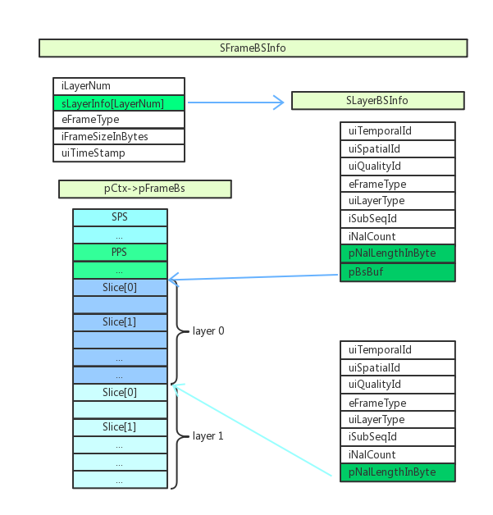

## 4.3 pCtx-pOut

### 

## 4.4. dynamic slice, slice boundary strategy

